Session 10-12
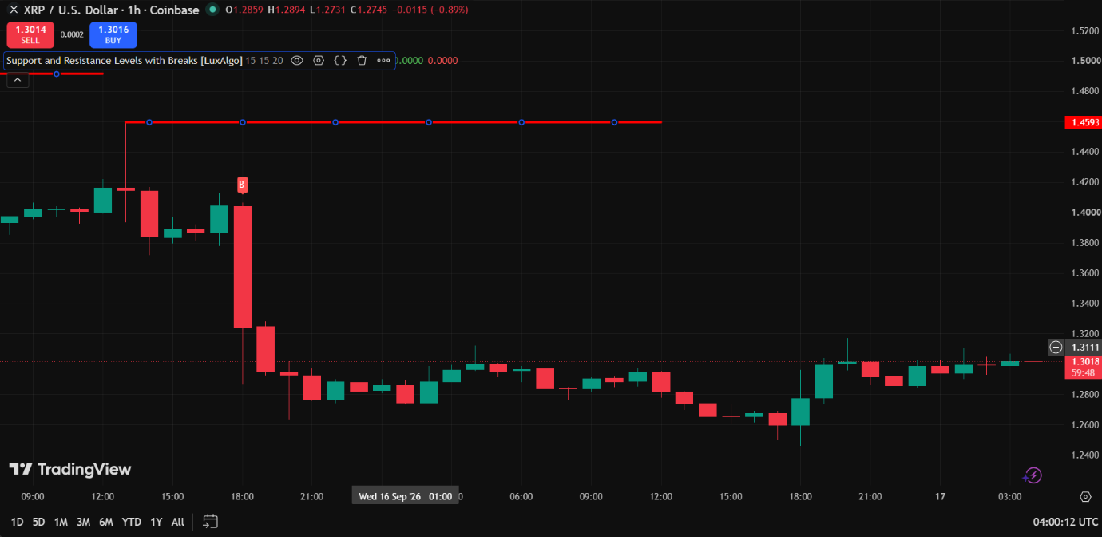
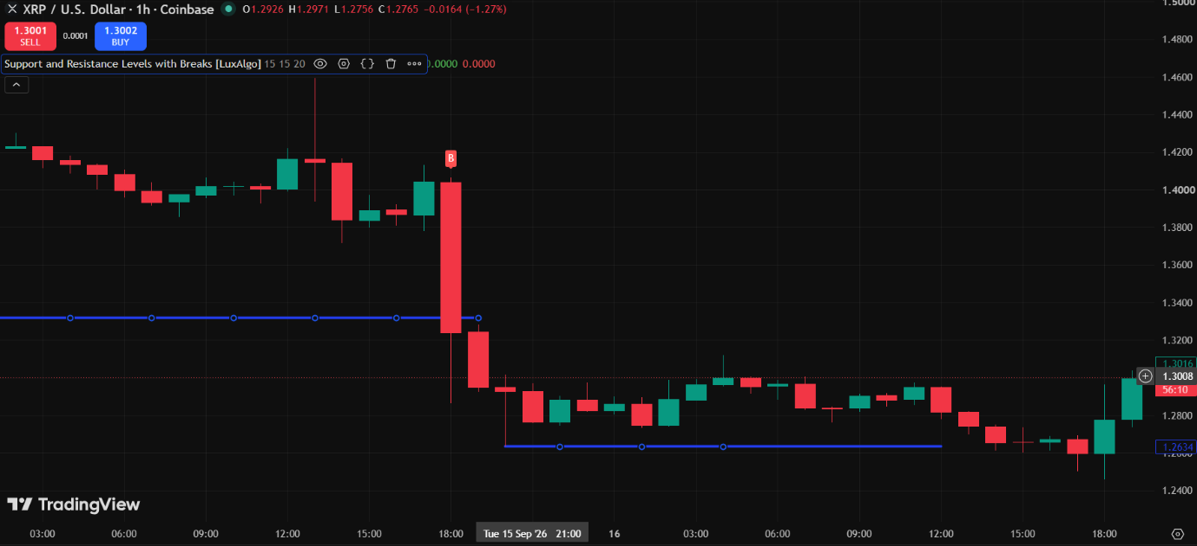
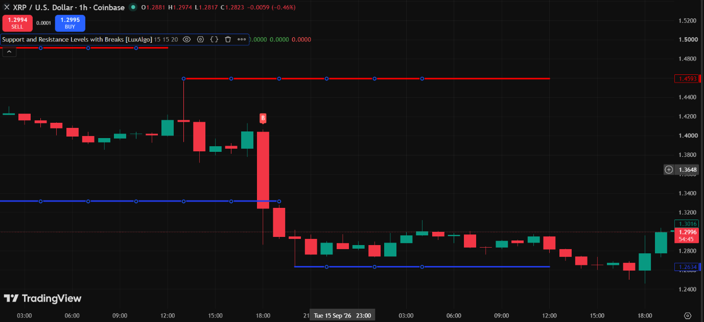
SUPPORT & RESISTANCE TRADE ANALYSIS REPORT
Chart Analysis

PARTICULARS | Observation
Asset Name | XRP
Symbol | XRPUSD
Timeframe | 1 Hour (1H)
Support Level | 1.2634
Resistance Level | 1.4593
Current price position( Near support/Near Resistance/ Between Levels) | 1.2996(Near support)

Trading Decisions

PARTICULARS | Observation
Trade Executed | Yes
Trade Type(Long /Short /No Trade) | Long
Reason For Trading Decision | The price is near the support level, suggesting a possible upward bounce.  Hence, a Long trade was taken expecting the price to move toward resistance.

Trade Details

Particular | Observation
Entry Price | 1.298
Exit Price | 1.298
Realized Profit/Loss | +0.03
Trade Outcome (Profit/Loss) | Profit

